PEHM501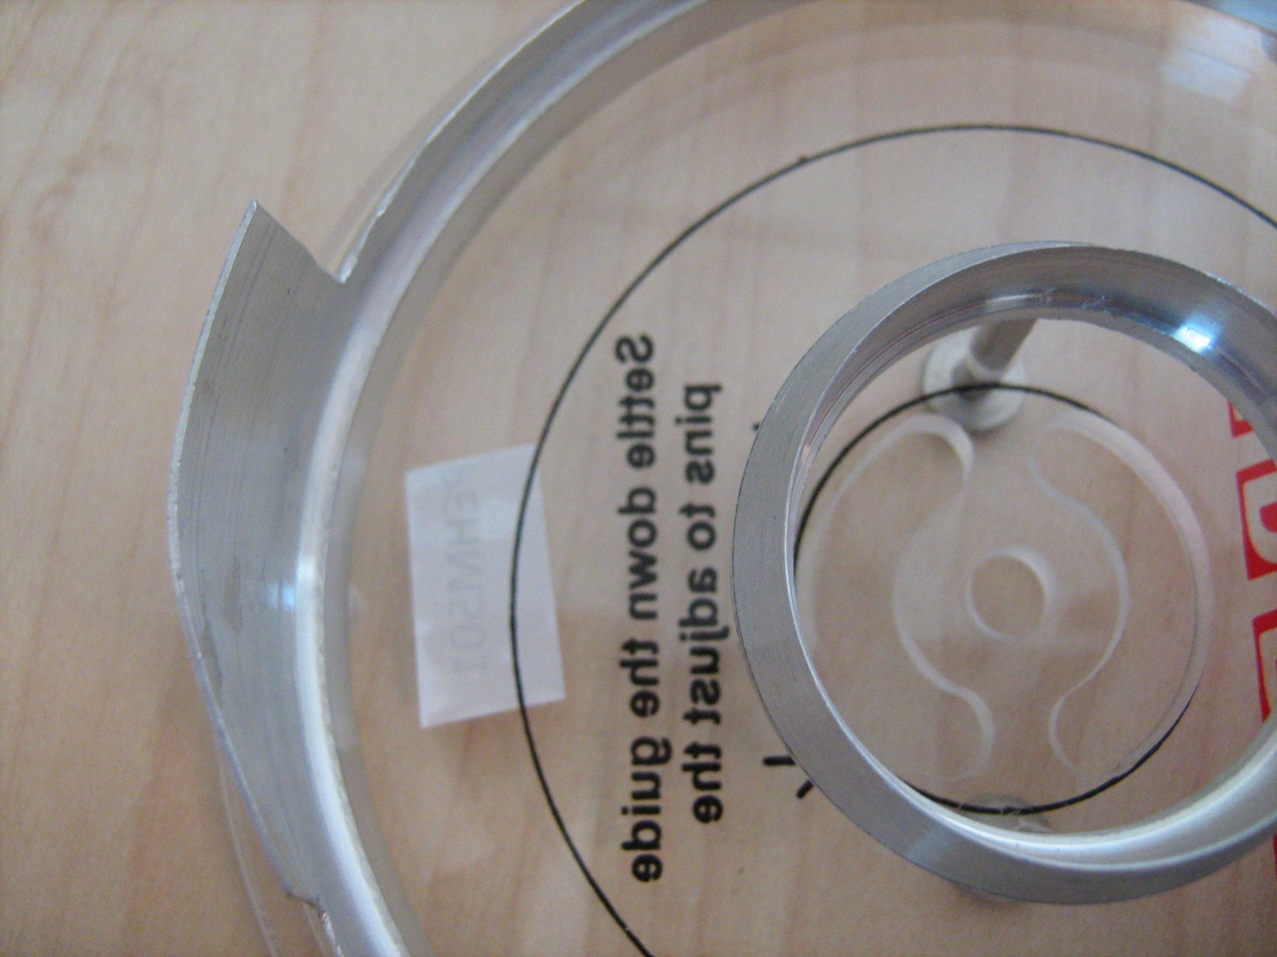
The metal part that holds the platters is bent and sharp. When comparing both there’s difference in the angle that the metal has.

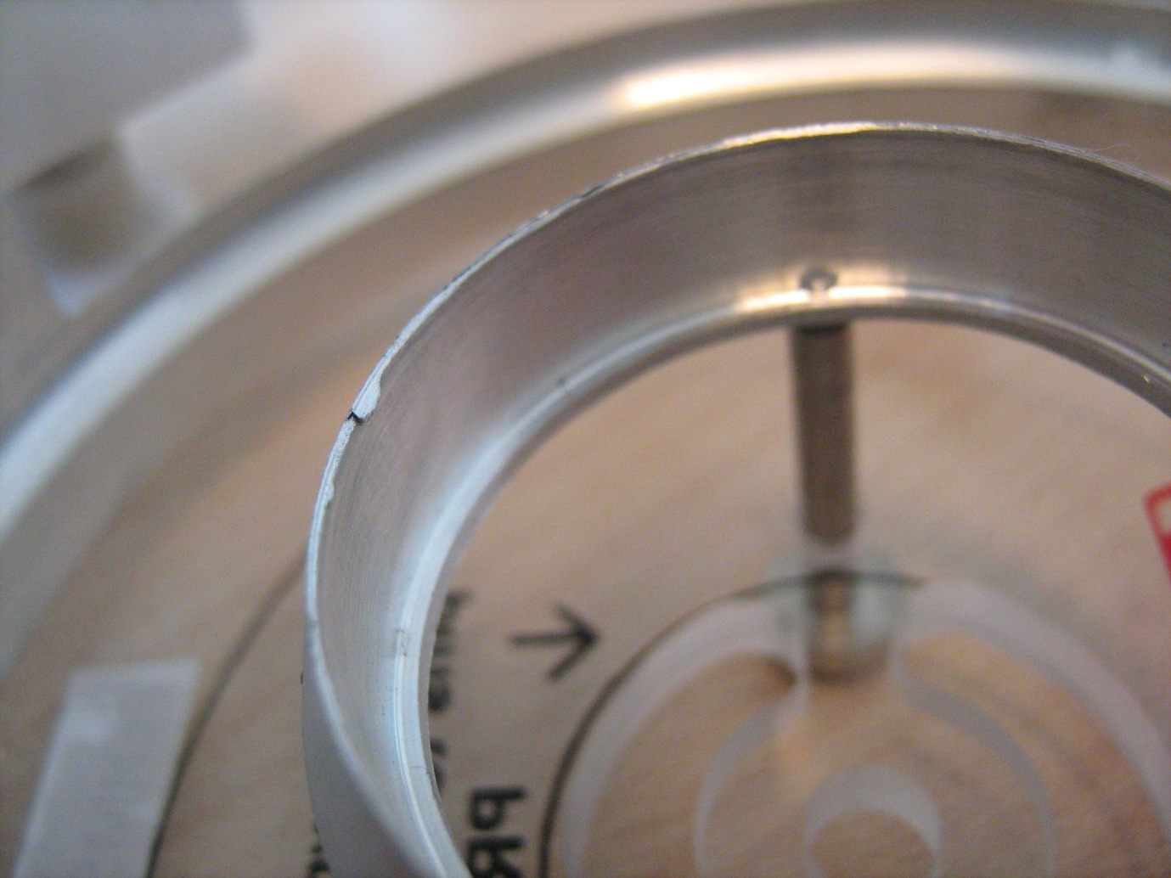
The inner metal that goes on the parking zone is not finished properly and scratches every surface it touches. Cut’s open your gloves and fingers when sliding past it.

