PEMS140
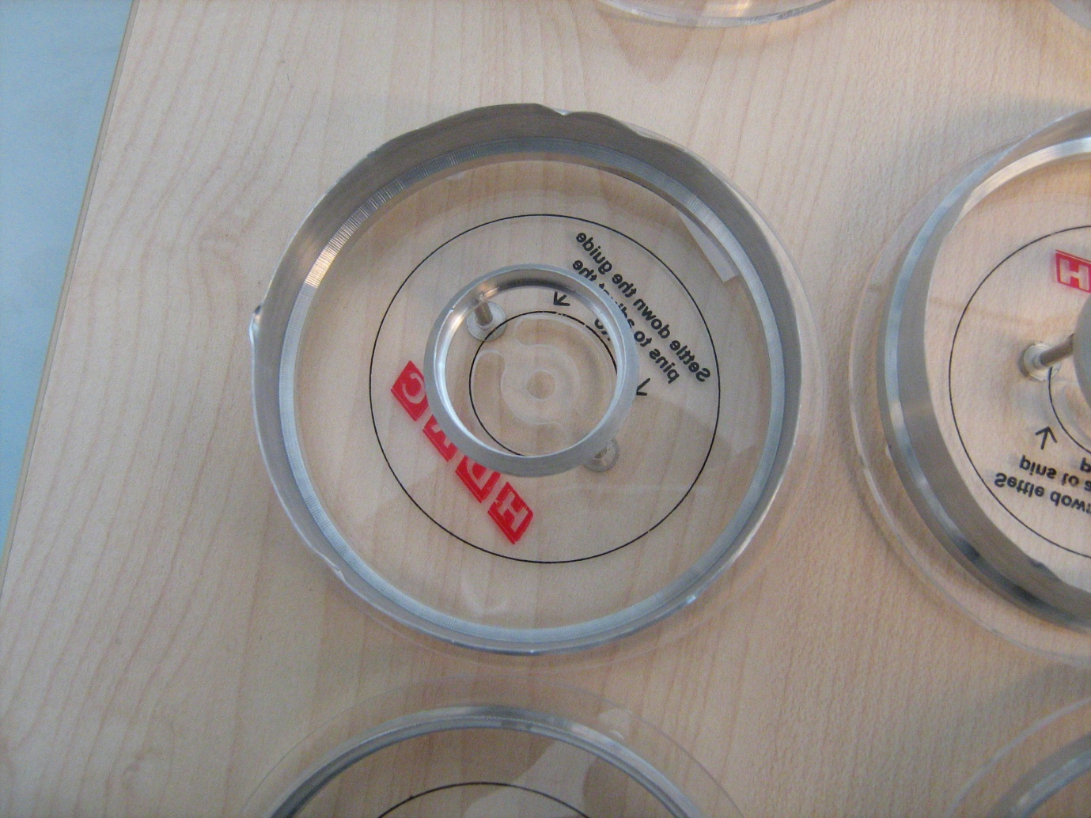
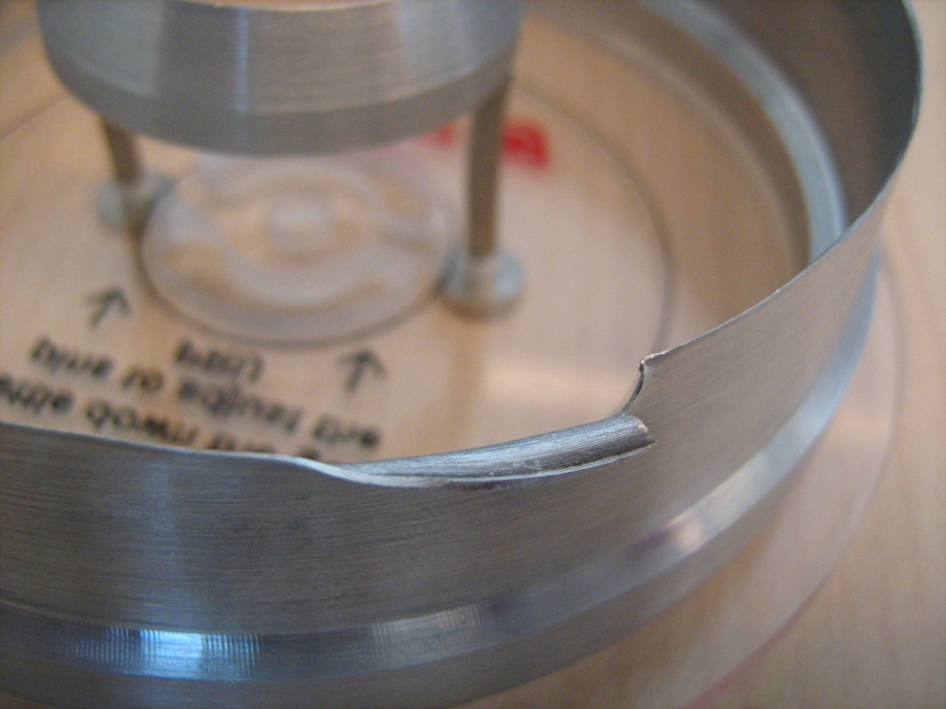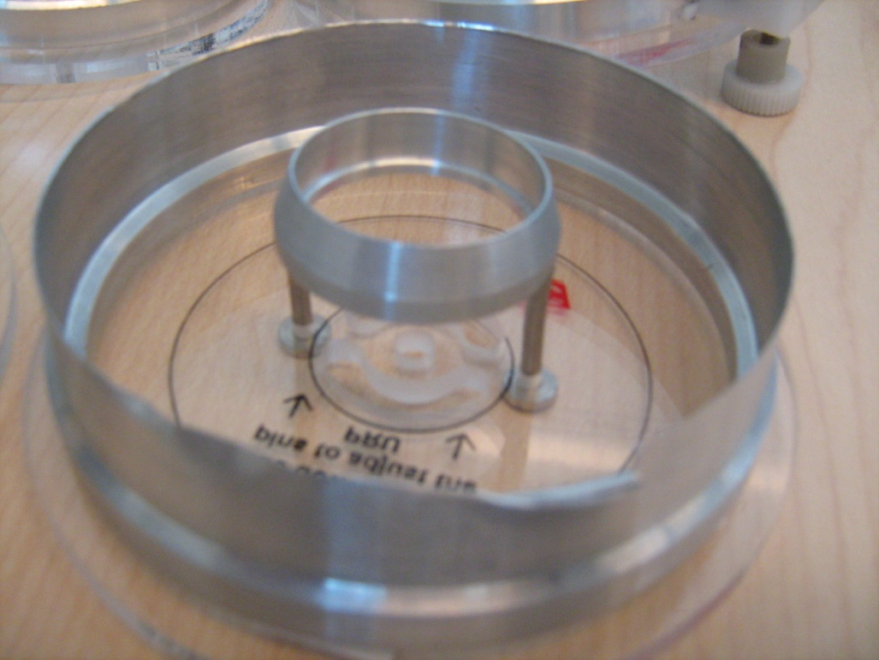
The metal is broken and bent outward. Multiple dents can be seen on the tool.
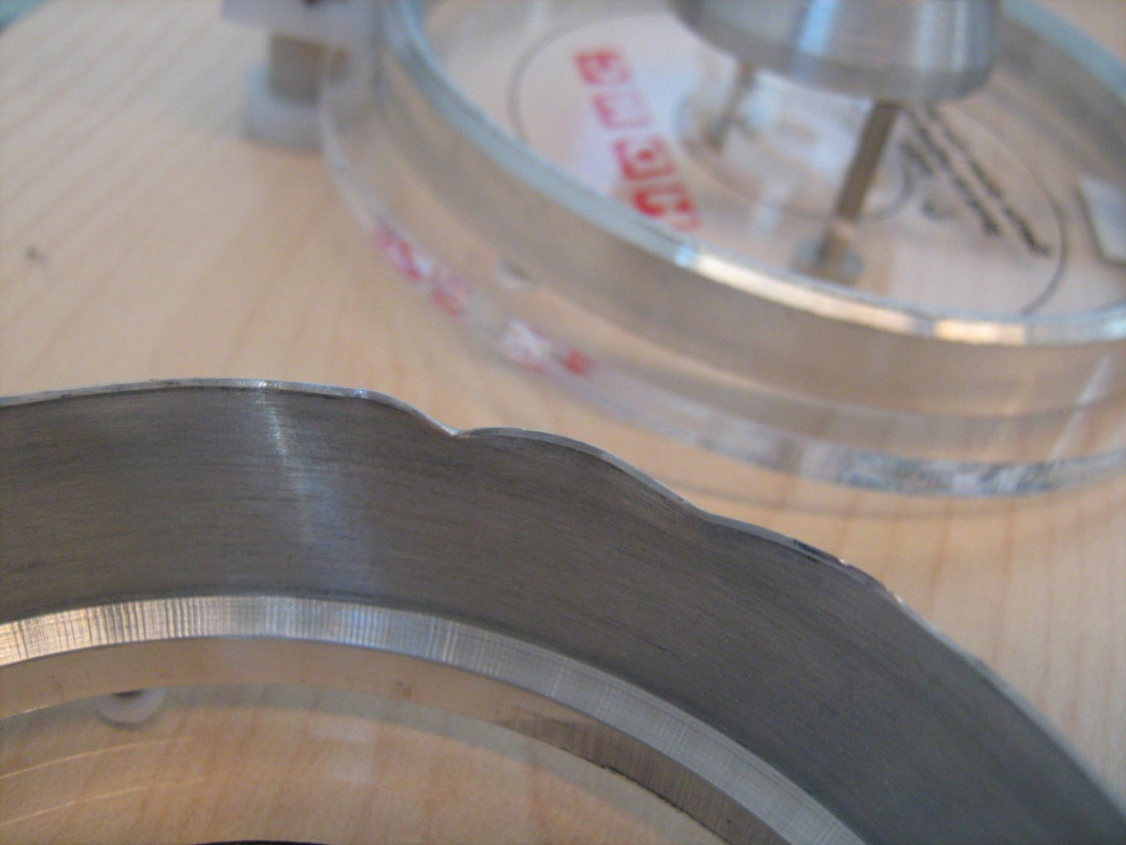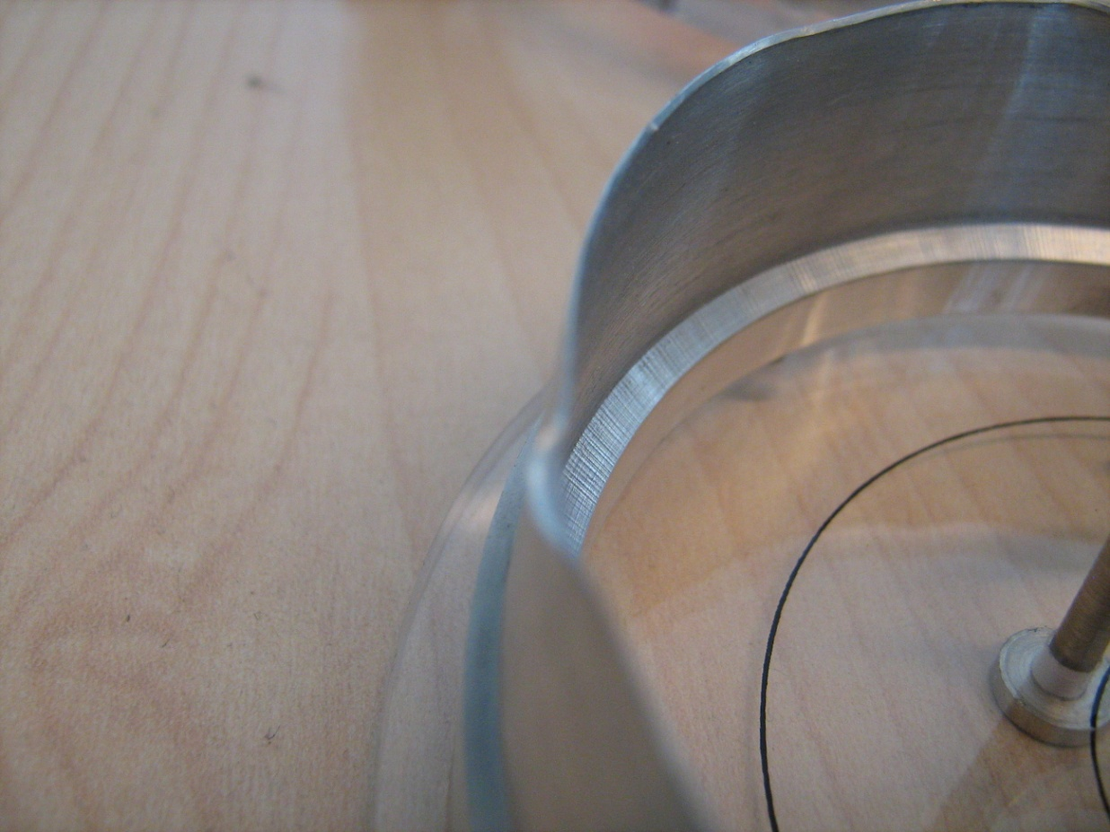
The other tool has a lot of dents as well. The metal is really sharp and easily cuts into gloves and fingers. How to hold the platters without the means to create the friction on the side of the platters.

