PESA8001
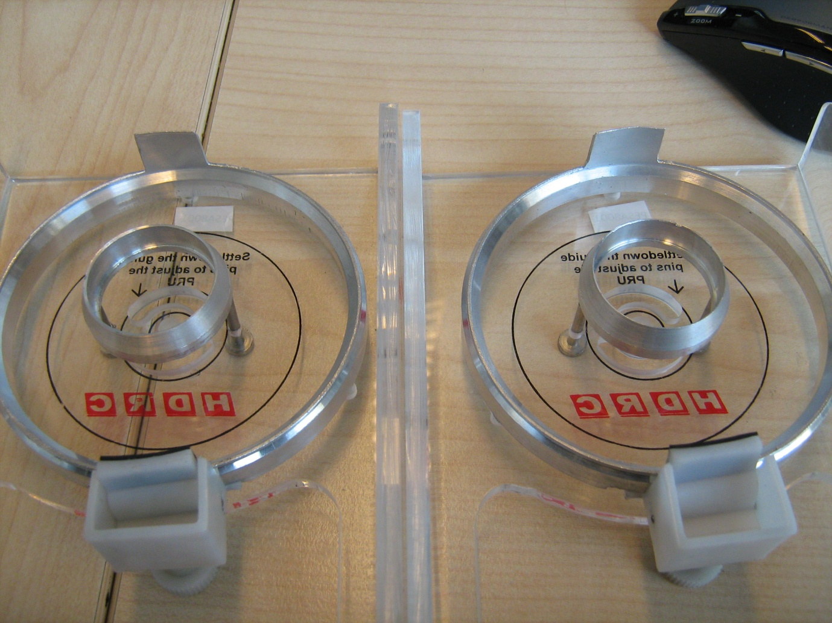
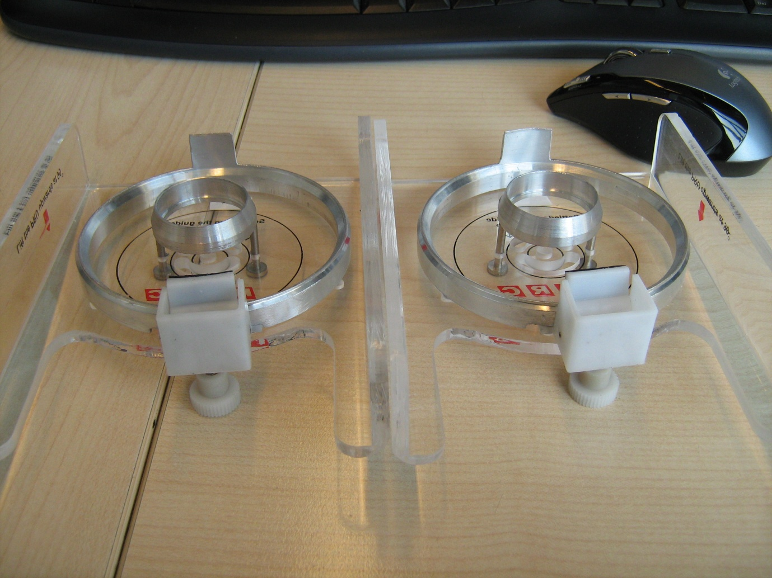
The metal pin for holding the platters is bent. On two identical tools the holders are on a different spot and a different size. The rubber holder for the platters is not correctly aligned.

