PESE0901
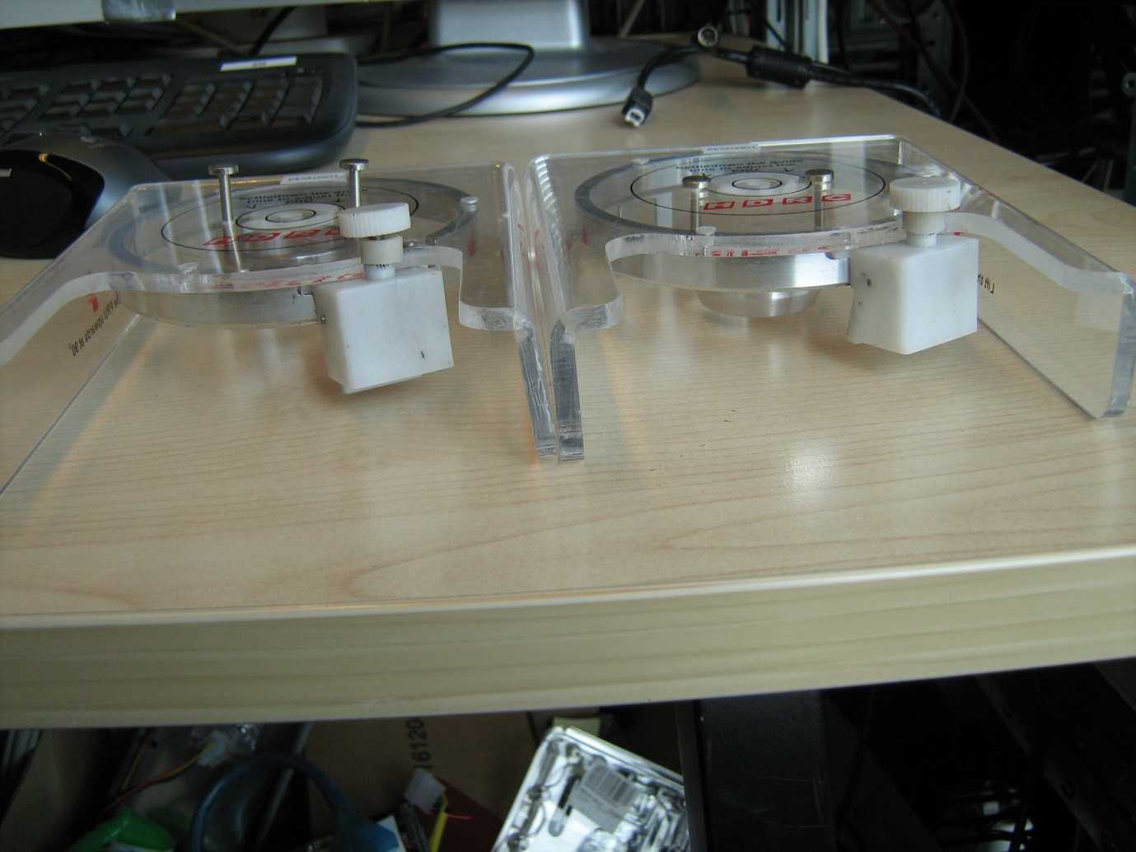

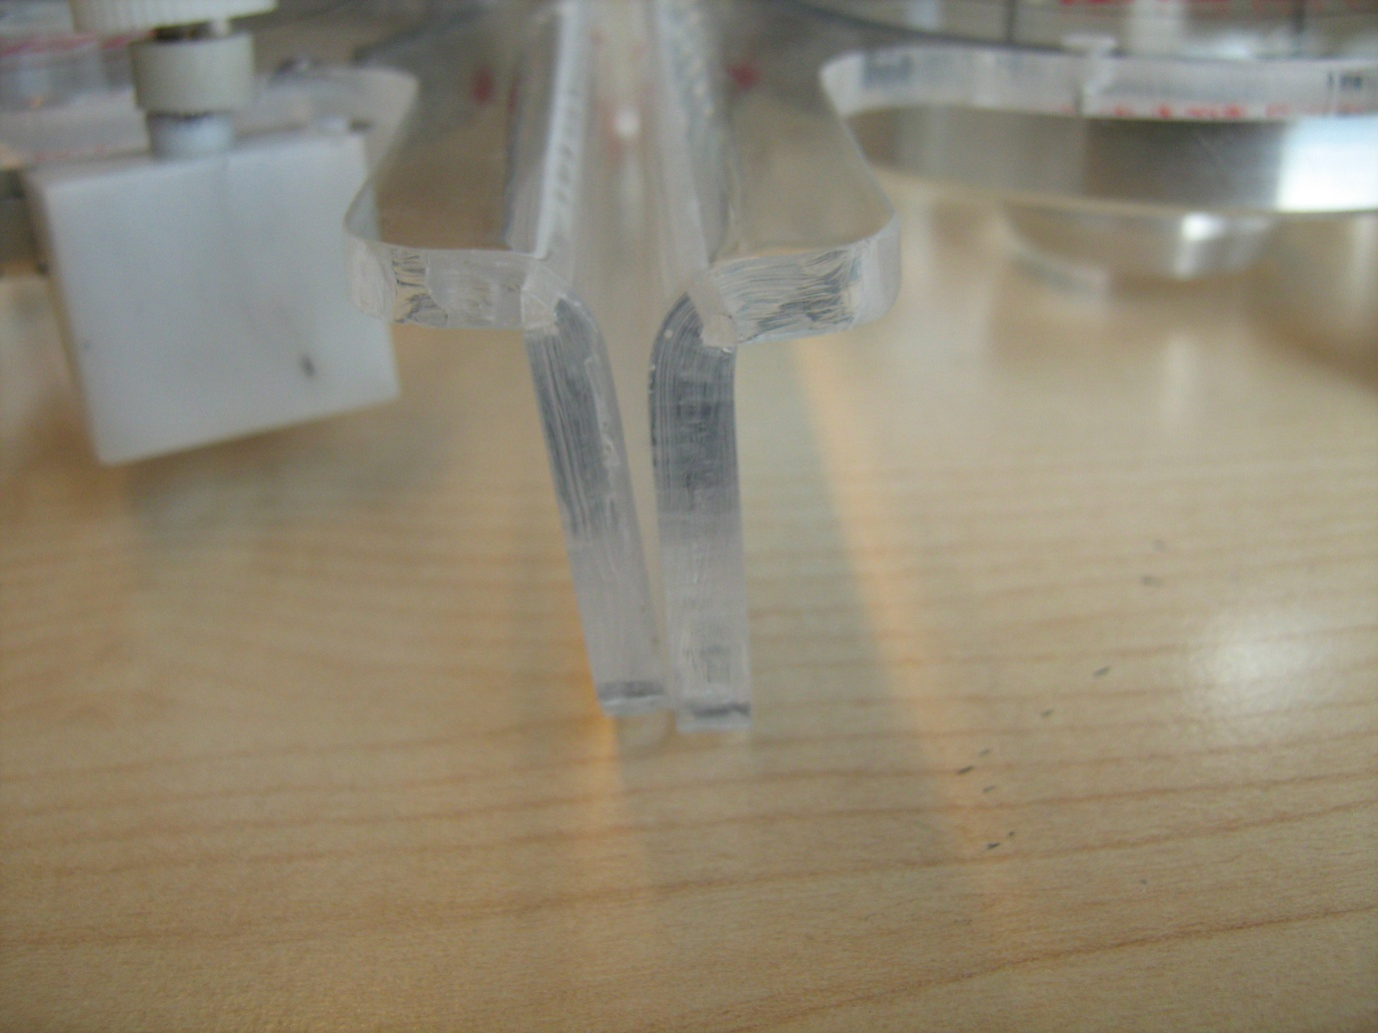
The two tools are not straight, there’s a lot of difference on both and one of the tools cannot be put down on a table normally.
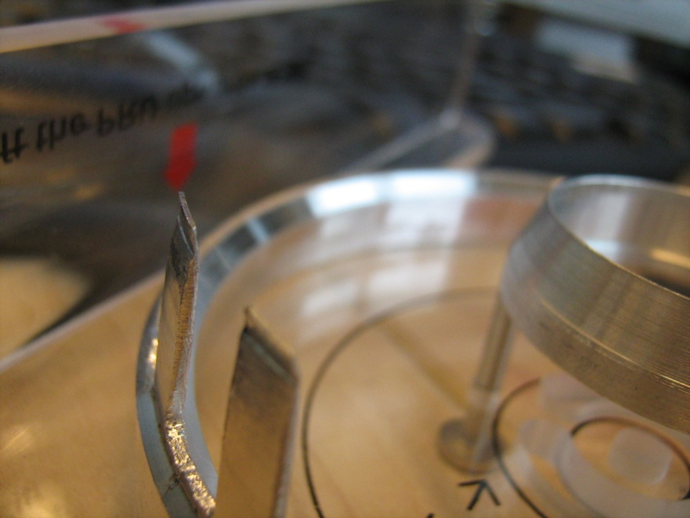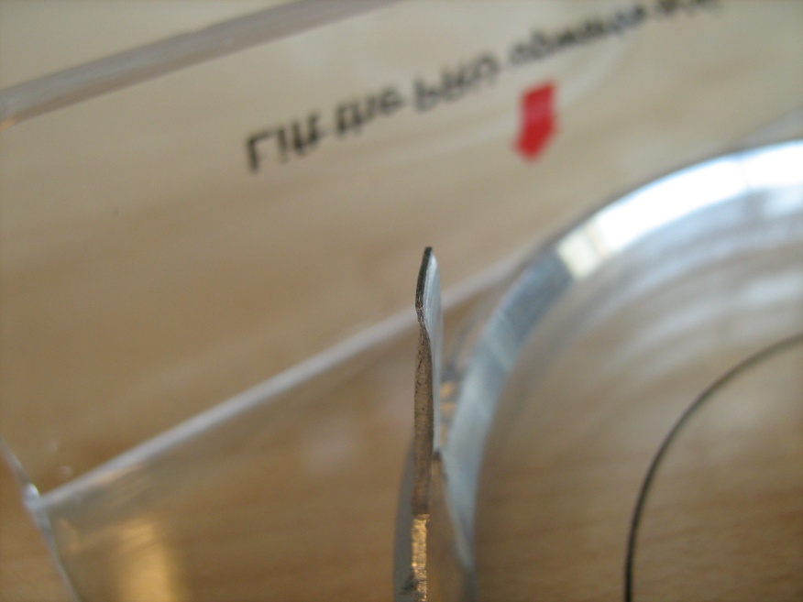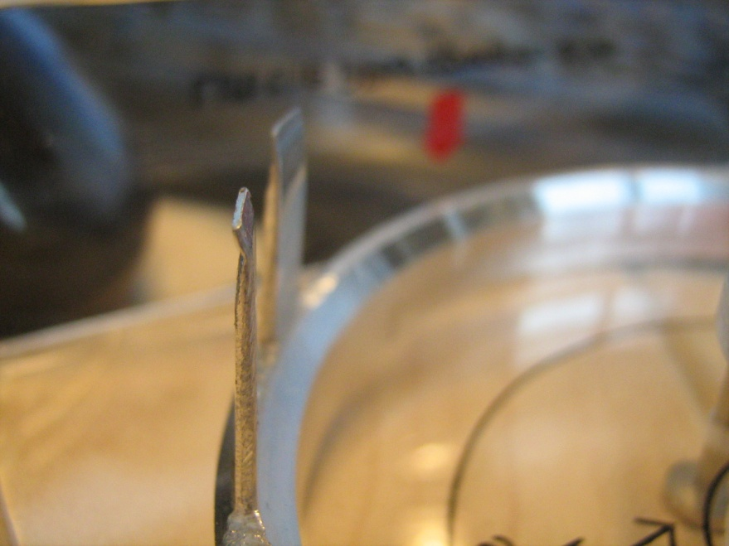
The two metal arms holding the platters are not finished and are both bent in a different angle.
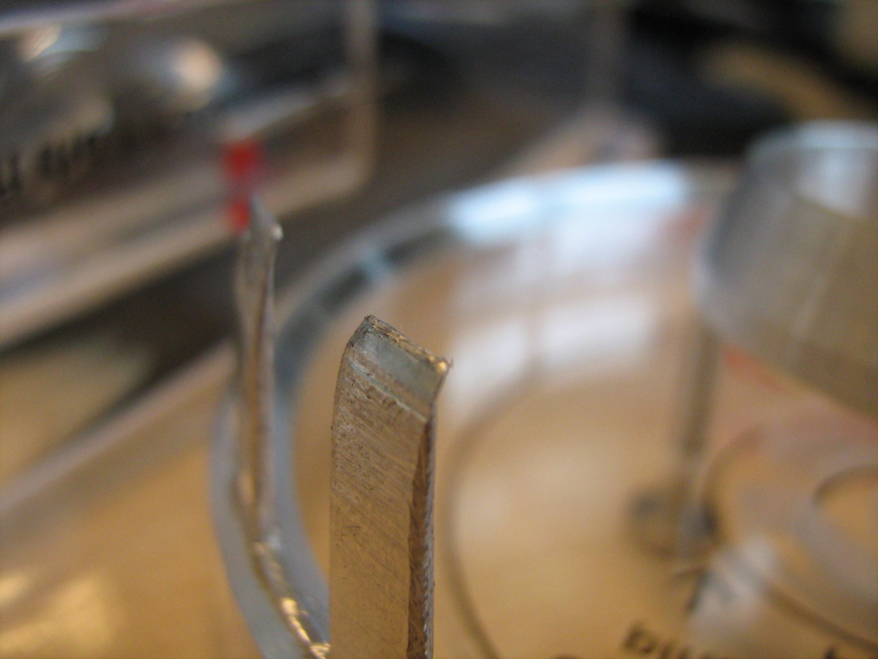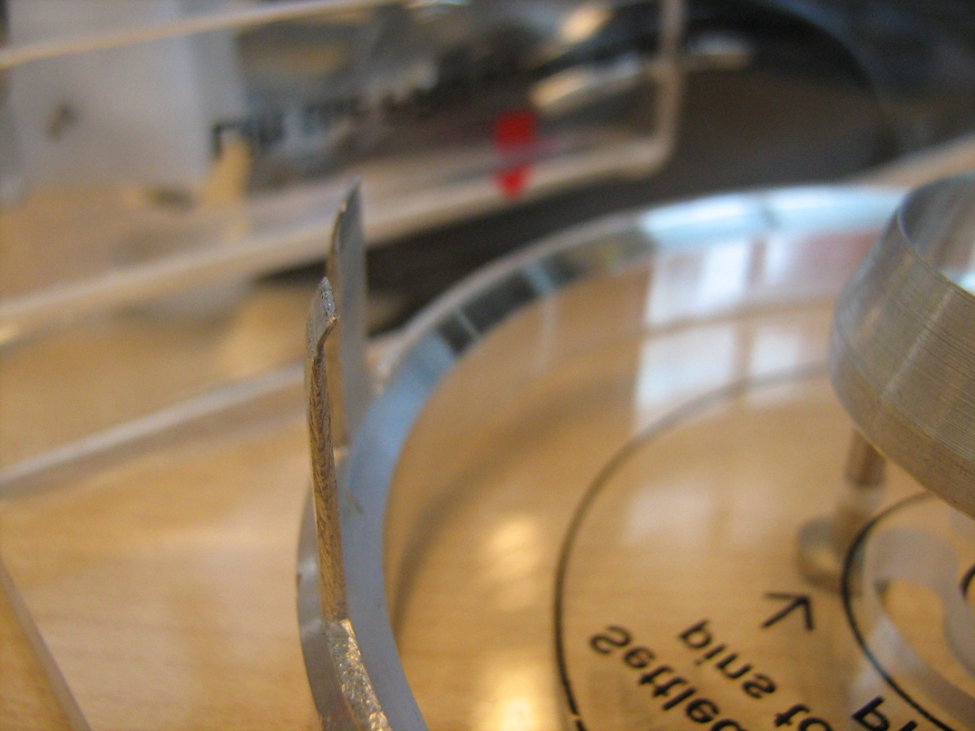
The other tool has the metal arms bent into a different direction and both have a different angle. The metal is pretty sharp.
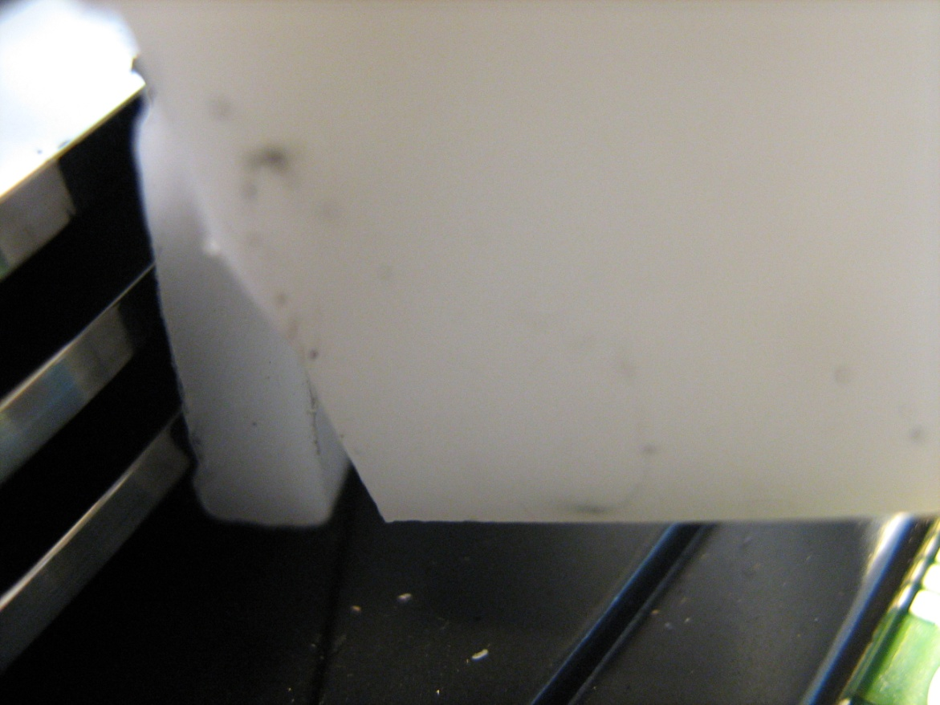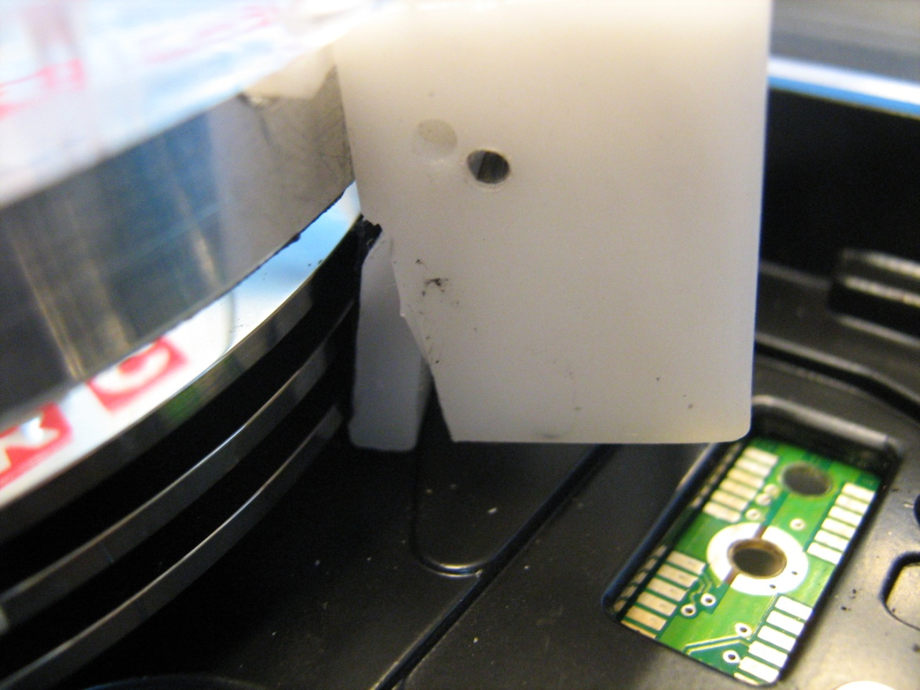
When the tool is put on a drive and pushed down as far as possible, the rubber holders do not touch all platters and create a lot of pressure on the bottom platter.
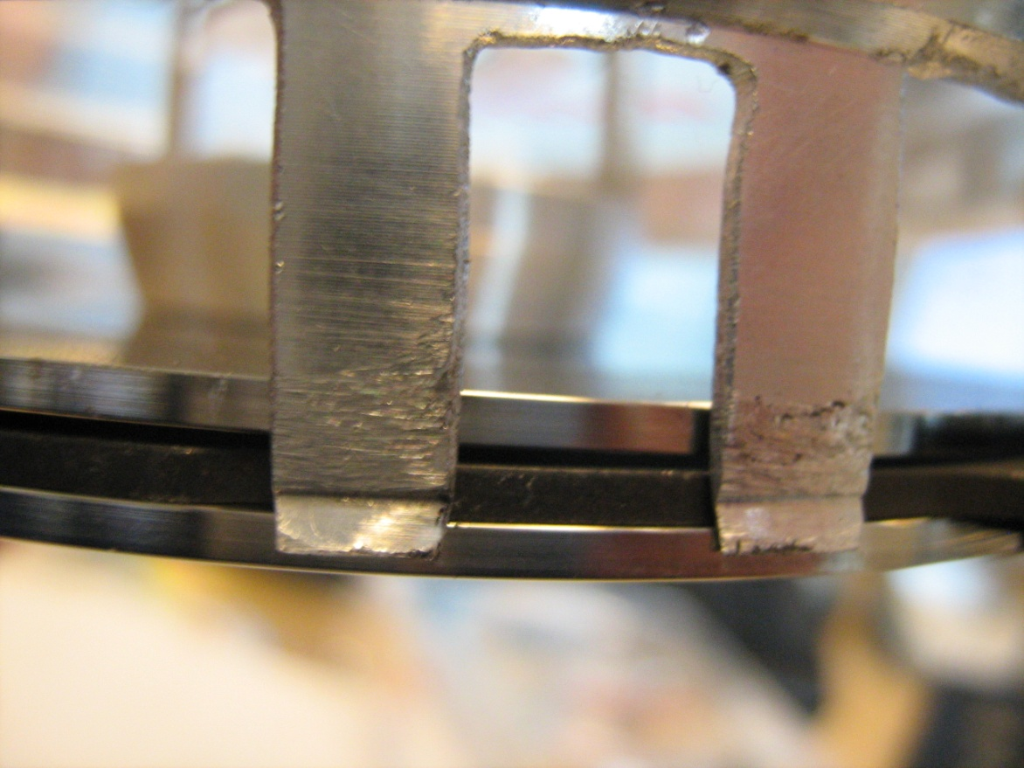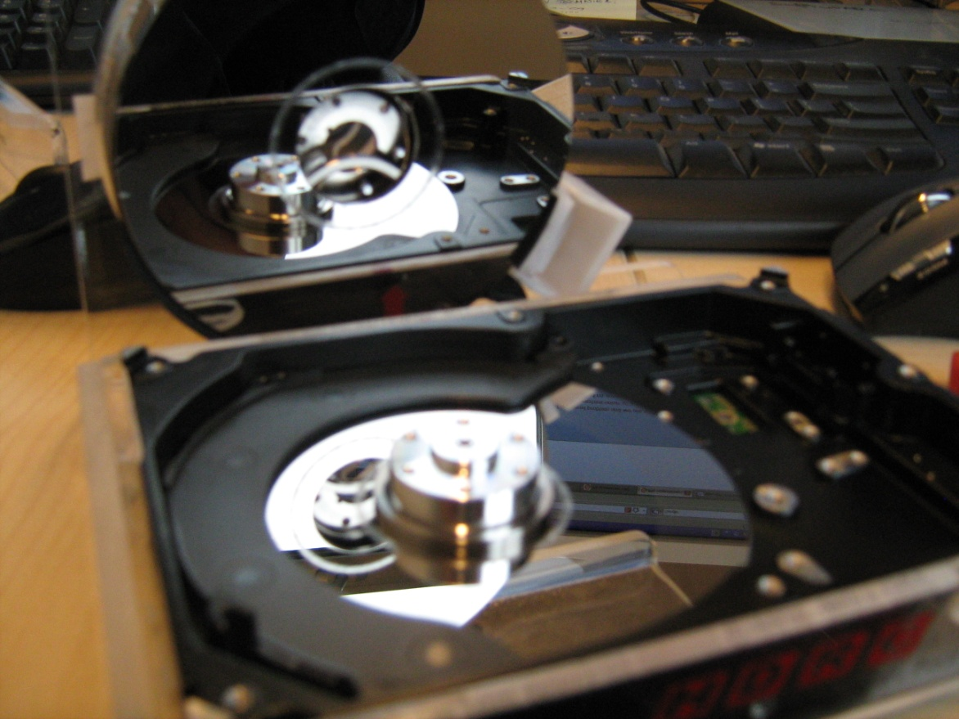
When the tool is put on the Seagate, it cannot get between the case and the platter, making it impossible to remove the 3rd platter. When putting the metal holders in place, a lot of damage is done to the side of the platter.
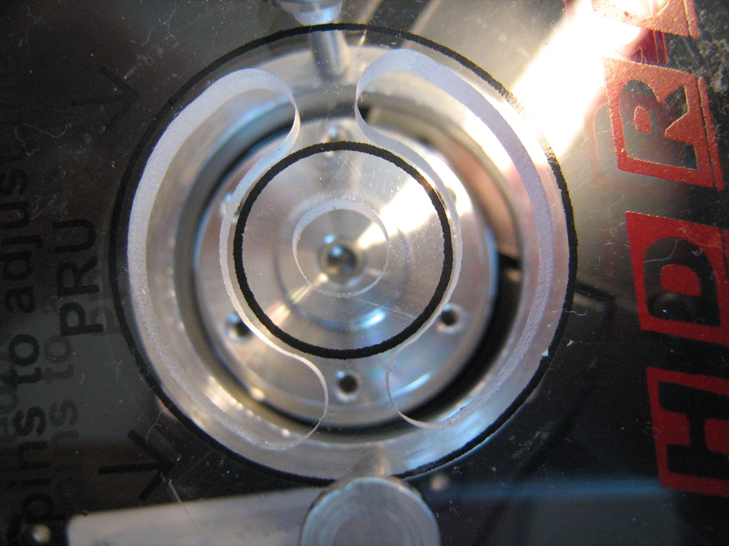
It’s impossible to align the spindle motor with the tool.


