PEWS401
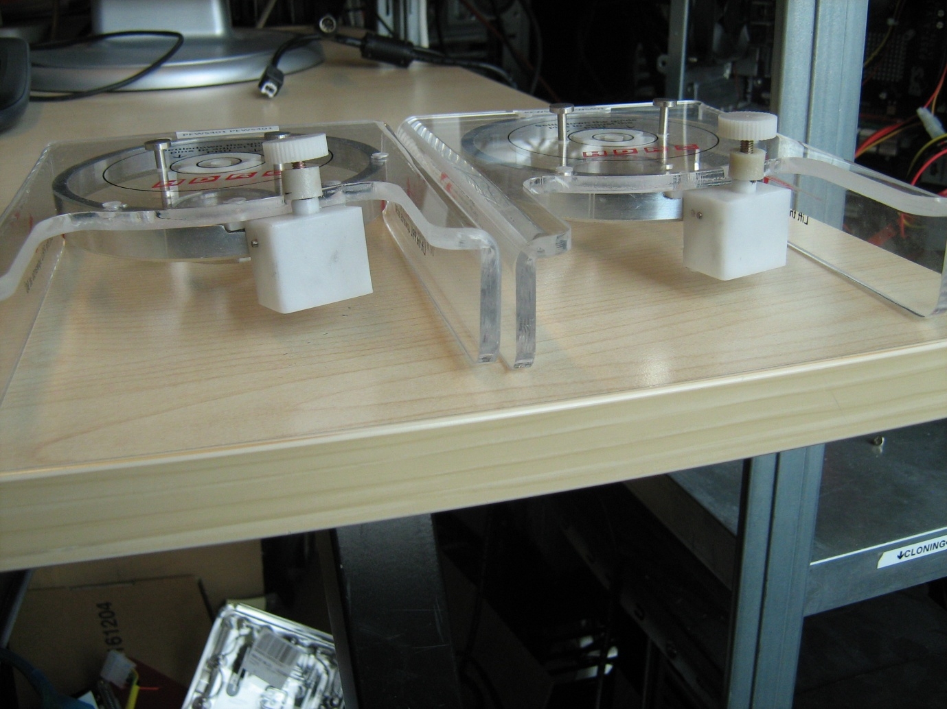
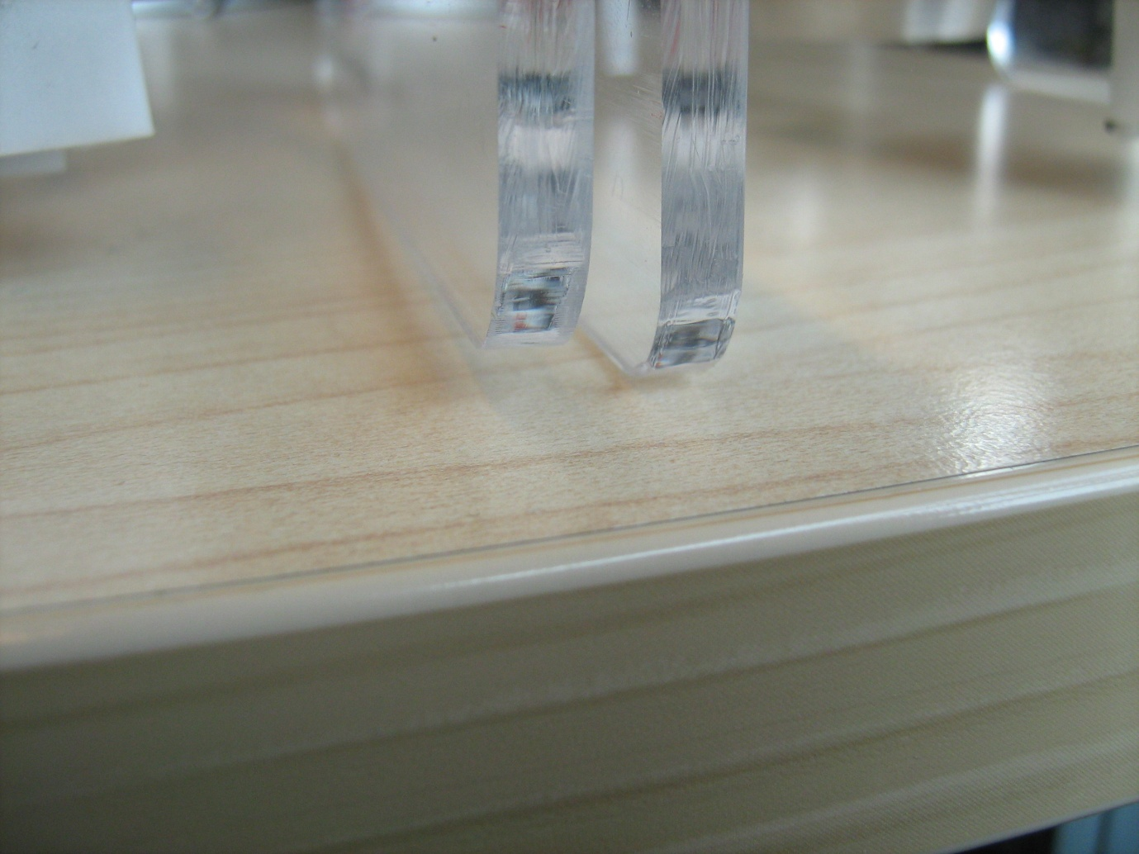
The tools are different, one of the tools cannot be put down on a table correctly.

