Fig-1: In disk management, shows unallocated disk, and asking to initialize the drive.
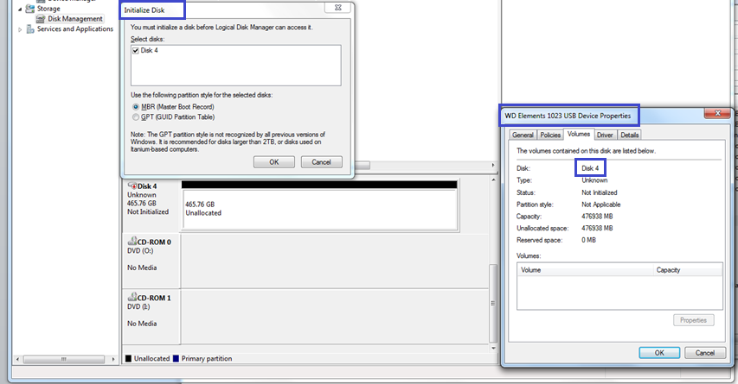

Fig-2: After clicking OK to “initialize Disk” Dialog Box, gives below write protected error


