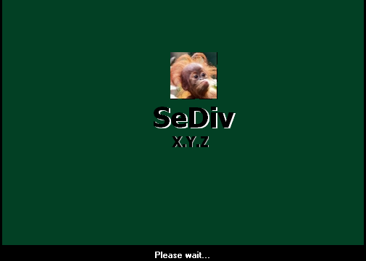

SEDIV MANUAL FOR WD
  - SEDIV WD MANUAL FOR BEGINNER

GET STARTED
- Get Started
  - Normal
  - Safe
  - Monitoring
- Resident Files (Experts)
  - Read resident file
  - Write resident file
  - Check resident file
  - Upload static file
  - Download from static to media file
- FMT Select
  - Get current format
  - Set HQ capacity
  - Set target Capacity
  - Set capacity
  - Set DCM
  - Get DCM
  - Set TPI
  - Read TPI
  - Write TPI
- Servo Cal (Experts)
  - Servo Spin UP
  - Servo Spin down
  - Servo actuator Head INIT
  - Servo calibration
  - Servo park
  - Servo get table data
  - Get current state of servo trace
  - Servo dynamic trace enable
  - Servo static trace enable
  - Servo get trace data
  - Disable servo trace
  - Issue gain calibration contact
- Drive Data Table (Experts)
  - Get current physical table
  - Get MR resistance table
  - Get zone table
  - Get RRO table
  - Get wedge zone table
  - Get drive TAA table
  - Get write sensitivity table
- Memory table (Experts)
  - Read memory table
  - Write memory table
  - Write immediate memory table
  - Read memory table-DRM group counters
  - Write immediate DRM counters group
  - Read static file
  - Write static file
  - Write immediate static file
- IBI
  - Clear IBI log
  - Set PST test
  - Clear abort section
  - Clear debug stop all
  - Clear debug stop ram
  - Clear factory file
  - IBI PK del
- Main
  - LBA G list
  - Clear g-list and relocate
  - F list edit
  - Init head 0
  - Init head 1
  - Init head 2
  - Load 11 overlay (From surface)
  - Load 13 overlay (from surface)
  - Create LDR
  - Check family name (FLASH)
- TEST (Experts)
- SA operation
  - Self SA
  - SA format
  - SA translator recalculation
  - Soft SA translator recalculation (ORIGINAL)
  - Soft SA translator recalculation (DETAIL)
  - SA module repair
  - Region read
  - Region edit
  - Create info file firmware
  - Zone cut
  - Capacity correct (IF CAPACITY ERROR AFTER CUT HEAD)
  - Unlock execute command
  - CHS scan SA
  - Disable slow
- Directory manager
  - Load directory and write fast
  - Repair dir universal – slow
  - Repair directory (VAR head, universal) – slow
  - Directory edit
  - Active directory change (0B<->20B)
  - LBA to CHS info
  - All modules info
  - Validate file system
  - Defrag directory
  - List directory
  - Expand directory
- Arco (Experts)
- Servo calibrate (Experts)
- Arco results
  - Mini ARCO results
  - WRRD GAP CAL result
  - Touchdown result
  - TPI CAL result
  - CKFCI head qualification result
  - Target search result
- Flash modules to surface (Experts)
- Security
  - Erase unit
  - Erase prepare
  - Disable password
  - Password clear
  - Freeze
  - Unlock
- Flash
  - Read ROM
  - Write ROM
  - Read ROM modules
  - Write ROM modules
  - View ROM modules
  - Head operation
  - Edit adaptive of head
- Memory
  - Read memory
  - Head map in RAM
- Modules
  - Read modules by ID
  - Write modules by ID
  - Read modules by ABA
  - Write modules by ABA
  - View module
  - Check
- Cylinder
  - Read cylinder
  - Write cylinder
  - Erase cylinder
- Read all
- Show defect list
- Clear defect list
- Smart
- Passport
- Format
- Translator
- Self test
- Calibrator (UA, SA)
- ARCO manual
- Calibrator 28
- Test 28 module run
- ATA scan
- CHS scan

A Brief introduction about function’s

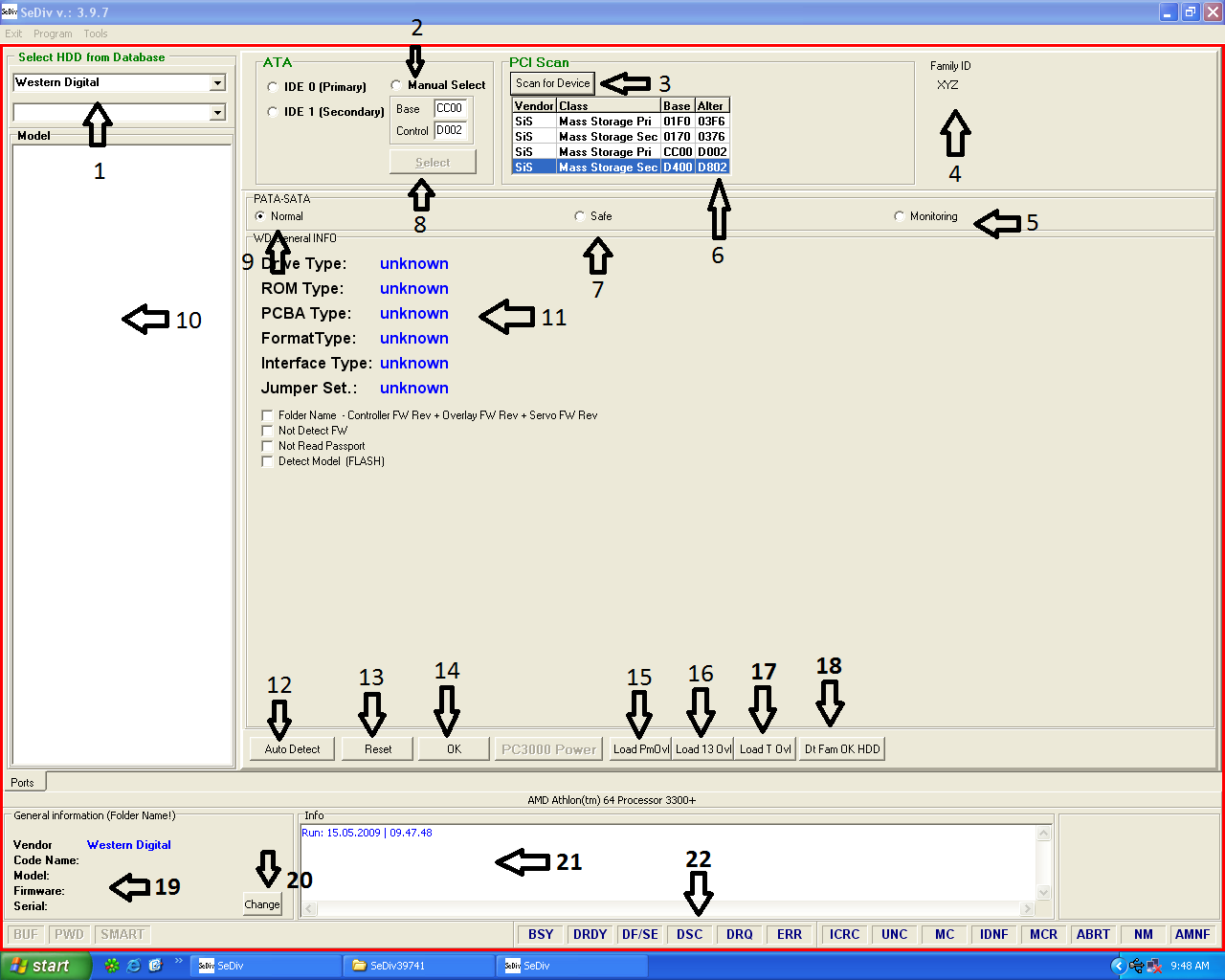
- GET STARTED

  - Select hard disk brand
  - Manual select port
  - Used to scan all motherboard ports. In simple words it gives u the access to all motherboard ports where you connect hard disks. And then you easily select the port where you connect the hard disk.
  - Family ID XYZ. This gives you the id name of hard disk family when u click on auto detect.
  - Monitoring. It is used to monitor self scan process.
  - Ports detail
  - Safe. If your hard disk is not in detection. You should select safe mode to get hard disk information (from ROM or PCB).
  - Used to select ports manually.
  - Normal. If your hard disk is in detection. You should select normal mode to get hard disk information like model, serial capacity, and other things.
  - Hard disk family selection, available only in Seagate and Hitachi.
  - Hard disk information
  - Auto detects. It is used to get all hard disk information auto like model number serial number and etc and then gives you access to program features.
  - Reset. It is used for soft reset.
  - Ok. After auto detects operation u need to press ok, it will enter you in the program.
  - Used to load permanent overlay in RAM(module # 11)
  - Used to load overlay in RAM (module # 13).
  - Used to load transient overlay in RAM (module # 12)
  - Data farm ok. If your hard disk not shows family name used this button to detect correct family name.
  - This is general information tab, shows hard disk model number and serial number and firmware number.
  - It is used to change hard disk serial number.
  - It is a info tab. It shows you the process which is running in the start of hard disk detection when u click on auto detect.
  - These are called hard disk registers.
- FMT SELECT.
- Get Current format
Whenever you click on get current format button you got this message. These are the details of hard disk which is set by ARCO. In this message you will see capacity, track density, sector density, capacity for every head, DCM, heads quantity original and used.
It has a very important role in hard disk repairing such as,
- When you set DCM to 1 all things in get current format set to factory default settings. If you disable head from ROM then it arrange used head reduced by number of heads which is reduced in ROM.
- Some time when you depop head and try to format hard disk with g and p list it gives you error (FMT ERROR CAPACITY).
For more info see experts manual

Format_version: 257
DCM Selection: 1 DCM DETAIL
Cur stroke: 1
Phy heads: 4 original head in ROM
Used heads: 3 HEADS WHICH IS USED BY FIRMWARE
Cur capacity: 1875 CAPACITY SELECTED BY ARCO
Final capacity_selection: 0
Max fmt LBAs: 366309216 = 174,67 GB MAX SEXTOR FOR FORMATING
Target capacity selection: 0
Target max_fmt LBAs: 0 = 0,00 Gb HARD DISK ORIGINAL CAPACITY
Hq capacity selection: 0
HQ max fmt LBAs: 366309216 = 174,67 Gb AS ABOVE
Reserved1: 0
Reserved2: 0
Reserved3: 0
Reserved4: 0

Zone 0 DTPI: 161796
Zone 0 KFCI: 1
Cur svo TPI: 190000
Cur_data_TPI_0: 185546 TPI FOR HEAD 0 SELECT BY ARCO
Cur_data_TPI_1: 190000 AS ABOVE
Cur_data_TPI_2: 190000 AS ABOVE
Cur_data_TPI_3: 0
Cur_data_TPI_4: 0
Cur_data_TPI_5: 0
Cur_data_TPI_6: 0
Cur_data_TPI_7: 0

Cur_KFCI_0: 625 CAPACITY OF HEAD 0 SELECT BY ARCO
Cur_KFCI_1: 625 AS ABOVE
Cur_KFCI_2: 625 AS ABOVE
Cur_KFCI_3: 0
Cur_KFCI_4: 0
Cur_KFCI_5: 0
Cur_KFCI_6: 0
Cur_KFCI_7: 0
Cur_KFCI_8: 0
Cur KFCI 9: 0

Max_LBA_for_head_0: 122103072 = 58,22 Gb CAPACITY FOR EVERY HEAD
Max_LBA_for_head_1: 122103072 = 58,22 Gb
Max_LBA_for_head_2: 122103072 = 58,22 Gb
Max_LBA_for_head_3: 0 = 0,00 Gb
Max_LBA_for_head_4: 0 = 0,00 Gb
Max_LBA_for_head_5: 0 = 0,00 Gb
Max_LBA_for_head_6: 0 = 0,00 Gb
Max_LBA_for_head_7: 0 = 0,00 Gb

Max_user_cyls_for_head_0: 89871 CYLINDER FOR EVERY HEAD
Max_user_cyls_for_head_1: 92024
Max_user_cyls_for_head_2: 92024
Max_user_cyls_for_head_3: 0
Max_user_cyls_for_head_4: 0
Max_user_cyls_for_head_5: 0
Max_user_cyls_for_head_6: 0
Max_user_cyls_for_head_7: 0

Max_virt_cyls_for_head_0: 113000
Max_virt_cyls_for_head_1: 115712
Max_virt_cyls_for_head_2: 115712
Max_virt_cyls_for_head_3: 0
Max_virt_cyls_for_head_4: 0
Max_virt_cyls_for_head_5: 0
Max_virt_cyls_for_head_6: 0
Max_virt_cyls_for_head_7: 0

Rsvd_svo_cyls: 256
Rsvd_data_cyls: 128
Trks_per_clstr_svo: 128
Trks_per_clstr_rsvd: 128

Trks_per_clstr_for_head_0: 125
Trks_per_clstr_for_head_1: 128
Trks_per_clstr_for_head_2: 128
Trks_per_clstr_for_head_3: 0
Trks_per_clstr_for_head_4: 0
Trks_per_clstr_for_head_5: 0
Trks_per_clstr_for_head_6: 0
Trks_per_clstr_for_head_7: 0

Stroke = 1
DCM = 1 CURRENT DCM SELECTION
- Set HQ capacity.
This function manually set the HQ capacity. It accepts value in hex format. If you not have experience then not plays with this. It manually changes the setting of capacity which is set by ARCO.
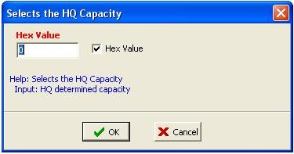

- Set target capacity.
This function manually set the target capacity. It accepts value in hex format. If you not have experience then not plays with this. It manually changes the setting of capacity which is set by ARCO.
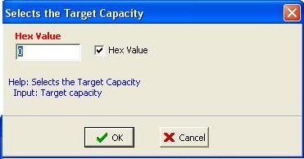

- Set capacity
This function manually set the capacity which is available in sector formatting later we will discuss it. It accepts value in hex format. If you not have experience then not plays with this. It manually changes the setting of capacity which is set by ARCO. If hard disk has one head then enter value in first integer and so on.

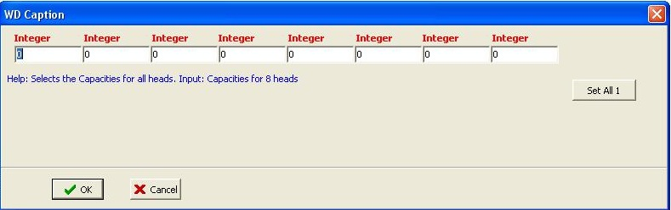
- Set DCM.
DCM set all the values of hard disk to its factory default setting.
(DCM not clear logs and defect list, it removes all ARCO setting from hard disk information).
Default value for DCM = 1.
- Get DCM.
It shows which DCM value is already set.
- SET TPI.
It is same like set capacity.

8. Main.
- LBA G list
This function is used to put LBA into g list directly.

- Clear G list and relocate.
This function used to clear G list and its translator if hard disk is slow responding. It clears modules directly.
- F list edit.
Field list has a very important role in hard disk refurbishing or repairing. It saves the capacity for all head which is available in hard disk ROM. Whenever you cut head it will auto select the downgrade capacity which is best for remaining heads. If field list is not having good capacity, then it will not set the proper capacity and in result you face many errors.
For example.
If you start ARCO tests on hard disk and forgot to set proper capacity for heads then 6a 6f 6b tests passed ok, but test 69 will stuck which is known as sector density.
Second example.
If a hard disk has 4 heads and 80 GB capacity for each head and total capacity is 320 GB. Now in F list it is important that every head has its capacity in that method which is below
Head 1 = 80 GB
Head 2 = 160 GB
Head 3 = 250 GB Head 3 = 350 GB
Head 4 = 320 GB
Now if you cut head 1 of a hard disk, then it changes all things and it load capacity from F list and save it in to the hard disk passport which is 250 GB. But if capacity for head 3 is 350 GB then it select 350 GB capacity and save it in hard disk passport. And after that whenever you try to format hard disk with P list it gives you error FMT_ERR_CAPACITY. Then you need to change capacity from F list manually.
How to Set F list?

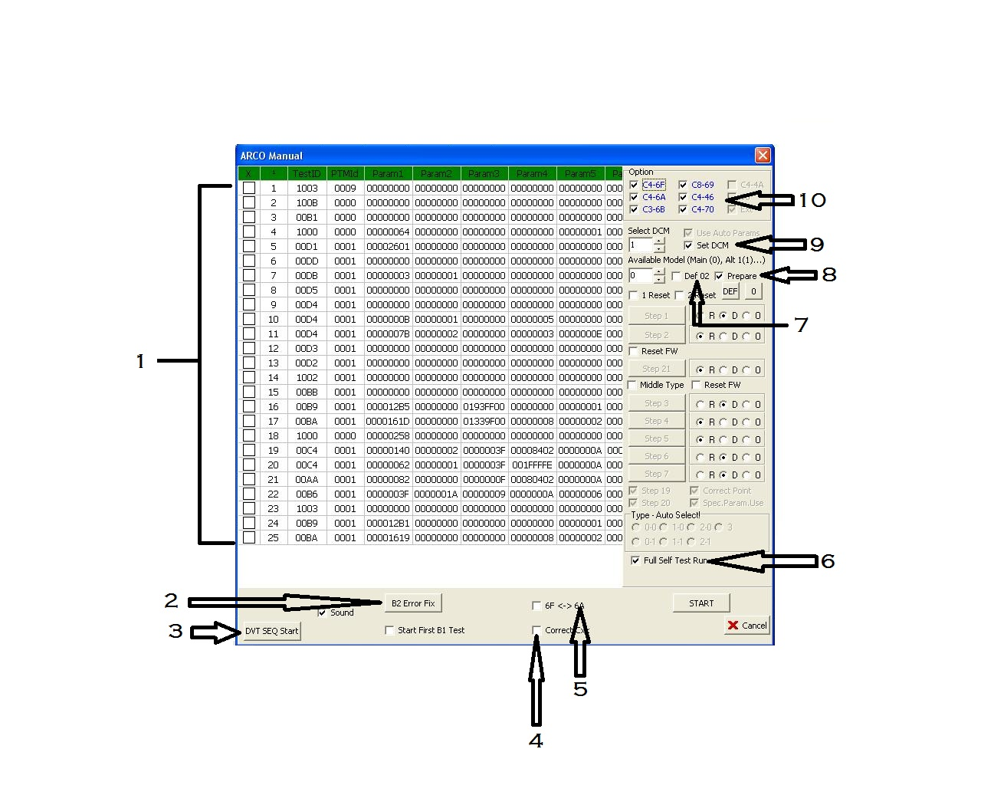
- ARCO MANUAL

- Self scan test ids which is available in module 28.
- B2 error fix. it is used to fix B2 error which is available in self scan script (module 28)
- It start DVT test first
- It corrects Cxx module parameters before running ARCO.
- ARCO sequence for maximum hard disk is 6f 6a 6b 69 46. But some hard disk not support this sequence so this function is used it change the sequence auto, it first start 6a then 6f 6b 69 46.
- If this is unable then complete self scan test run which is available in module 28 which is also known as self scan script.
- This function edit module number 02 which is called hard disk id module contain hard disk model and serial number. When you check this function and start ARCO it changes hard disk model number to xyz and serial number 0000. Some hard disk not supports module 02 changes.
- This option used to prepare all modules to run ARCO. By select this option and start ARCO first it clear all logs of ARCO (20xx modules) and all SS logs, if you not select this and start ARCO then it start ARCO without clearing modules.
- This option is used to set the corresponding DCM value. Recommended value is 1 it set hard disk information to its factory settings.
- Now this is a newly added function for ARCO which auto load all ARCO set from hard disk logs, if logs are empty then these test not appear. This section of ARCO work only if ARCO result modules are not empty (20XX modules). You can select or deselect any test which you not want to run.

Chart for manual ARCO.

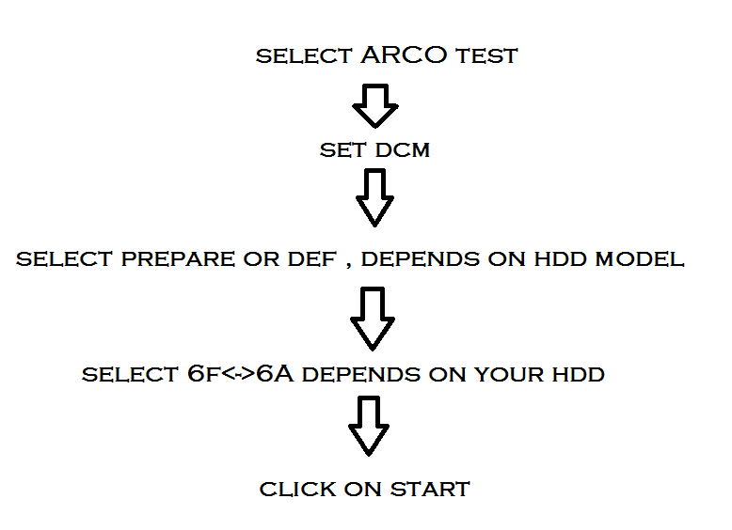

After start manual ARCO what it changes.
- Clear Arco logs (20XX modules)
- Clear SF logs.
- Clear all defect lists
- Set DCM to 1 and set all parameter to factory default setting if you set prepare function otherwise it only clear logs.
- If u set DEF function then it changes its id model to its factory setting.
- Unlock self scan which is in latest hard disk.
- Start ARCO.
- Wait for its finish, after complete ARCO from 6f 6a 6b 69 46 you can remove hard disk from software and plug it on separate power supply for 12 hour. Because self scan test run in background auto.

