SEDIV FOR WD HARD DISK
2014
Written by Waqas Ali
Software design by
WWW.SEDIV.NET
WWW.HDDREPAIRING.COM
WAQASALI766@HOTMAIL.COM
2/10/2014
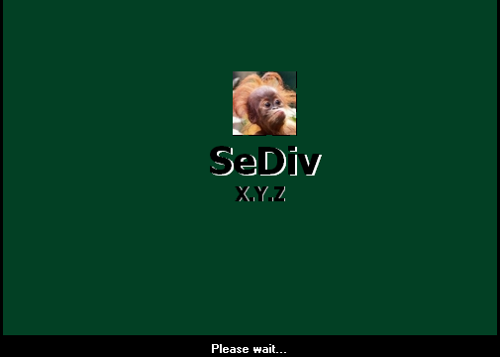

SEDIV MANUAL FOR WD
  - SEDIV WD MANUAL FOR BEGINNER

GET STARTED
- Get Started
  - Normal
  - Safe
  - Monitoring
- Resident Files (Experts)
  - Read resident file
  - Write resident file
  - Check resident file
  - Upload static file
  - Download from static to media file
- FMT Select
  - Get current format
  - Set HQ capacity
  - Set target Capacity
  - Set capacity
  - Set DCM
  - Get DCM
  - Set TPI
  - Read TPI
  - Write TPI
- Servo Cal (Experts)
  - Servo Spin UP
  - Servo Spin down
  - Servo actuator Head INIT
  - Servo calibration
  - Servo park
  - Servo get table data
  - Get current state of servo trace
  - Servo dynamic trace enable
  - Servo static trace enable
  - Servo get trace data
  - Disable servo trace
  - Issue gain calibration contact
- Drive Data Table (Experts)
  - Get current physical table
  - Get MR resistance table
  - Get zone table
  - Get RRO table
  - Get wedge zone table
  - Get drive TAA table
  - Get write sensitivity table
- Memory table (Experts)
  - Read memory table
  - Write memory table
  - Write immediate memory table
  - Read memory table-DRM group counters
  - Write immediate DRM counters group
  - Read static file
  - Write static file
  - Write immediate static file
- IBI
  - Clear IBI log
  - Set PST test
  - Clear abort section
  - Clear debug stop all
  - Clear debug stop ram
  - Clear factory file
  - IBI PK del
- Main
  - LBA G list
  - Clear g-list and relocate
  - F list edit
  - Init head 0
  - Init head 1
  - Init head 2
  - Load 11 overlay (From surface)
  - Load 13 overlay (from surface)
  - Create LDR
  - Check family name (FLASH)
- TEST (Experts)
- SA operation
  - Self SA
  - SA format
  - SA translator recalculation
  - Soft SA translator recalculation (ORIGINAL)
  - Soft SA translator recalculation (DETAIL)
  - SA module repair
  - Region read (Experts)
  - Region edit (Experts)
  - Region copy (write) {Experts}
  - Region -> Modules
  - Create info file firmware
  - Zone cut (Experts)
  - Capacity correct (IF CAPACITY ERROR AFTER CUT HEAD)
  - Unlock execute command
  - CHS scan SA (Experts)
  - Disable slow
- Directory manager
  - Load directory and write fast
  - Repair dir universal – slow
  - Repair directory (VAR head, universal) – slow
  - Directory edit
  - Active directory change (0B<->20B)
  - LBA to CHS info
  - All modules info
  - Validate file system
  - Defrag directory
  - List directory
  - Expand directory
- Arco (Experts)
- Servo calibrate (Experts)
- Arco results
  - Mini ARCO results
  - WRRD GAP CAL result
  - Touchdown result
  - TPI CAL result
  - CKFCI head qualification result
  - Target search result
- Flash modules to surface (Experts)
- Security
  - Erase unit
  - Erase prepare
  - Disable password
  - Password clear
  - Freeze
  - Unlock
- Flash
  - Read ROM
  - Write ROM
  - Read ROM modules
  - Write ROM modules
  - View ROM modules
  - Head operation
  - Edit adaptive of head
- Memory
  - Read memory
  - Head map in RAM
  - Head cut
- Modules
  - Read modules by ID
  - Write modules by ID
  - Read modules by ABA
  - Write modules by ABA
  - View module
  - Check
- Cylinder
  - Read cylinder
  - Write cylinder
  - Erase cylinder
- Read all
- Show defect list
- Clear defect list
- Smart
- Passport
- Format
- Translator
- Self test
- Calibrator (UA, SA)
- ARCO manual
- Calibrator 28
- Test 28 module run
- ATA scan
- CHS scan

A Brief introduction about function’s
- GET STARTED

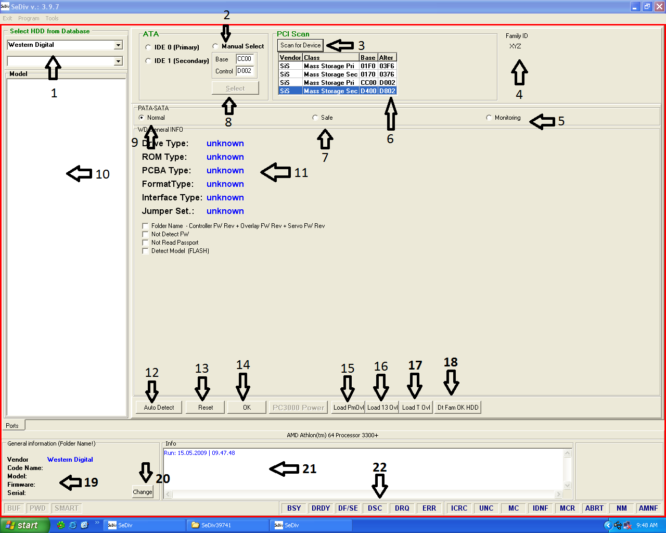
  - Select hard disk brand
  - Manual select port
  - Used to scan all motherboard ports. In simple words it gives u the access to all motherboard ports where you connect hard disks. And then you easily select the port where you connect the hard disk.
  - Family ID XYZ. This gives you the id name of hard disk family when u click on auto detect.
  - Monitoring. It is used to monitor self scan process.
  - Ports detail
  - Safe. If your hard disk is not in detection. You should select safe mode to get hard disk information (from ROM or PCB).
  - Used to select ports manually.
  - Normal. If your hard disk is in detection. You should select normal mode to get hard disk information like model, serial capacity, and other things.
  - Hard disk family selection, available only in Seagate and Hitachi.
  - Hard disk information
  - Auto detects. It is used to get all hard disk information auto like model number serial number and etc and then gives you access to program features.
  - Reset. It is used for soft reset.
  - Ok. After auto detects operation u need to press ok, it will enter you in the program.
  - Used to load permanent overlay in RAM(module # 11)
  - Used to load overlay in RAM (module # 13).
  - Used to load transient overlay in RAM (module # 12)
  - Data farm ok. If your hard disk not shows family name used this button to detect correct family name.
  - This is general information tab, shows hard disk model number and serial number and firmware number.
  - It is used to change hard disk serial number.
  - It is an info tab. It shows you the process which is running in the start of hard disk detection when u click on auto detect.
  - These are called hard disk registers.
- FMT SELECT.
- Get Current format
Whenever you click on get current format button you got this message. These are the details of hard disk which is set by ARCO. In this message you will see capacity, track density, sector density, capacity for every head, DCM, heads quantity original and used.
It has a very important role in hard disk repairing such as,
- When you set DCM to 1 all things in get current format set to factory default settings. If you disable physical head from ROM and set DCM to 1 then it will change logical heads from get current (used heads tab) reduced by number of physical head change in ROM.
- Some time when you cut head and try to format hard disk with g and p list it gives you error (FMT ERROR CAPACITY).
For more info see experts manual

Format_version: 257
DCM Selection: 1 DCM DETAIL
Cur stroke: 1
Phy heads: 4 original head in ROM
Used heads: 3 HEADS WHICH IS USED BY FIRMWARE
Cur capacity: 1875 CAPACITY SELECTED BY ARCO
Final capacity_selection: 0
Max fmt LBAs: 366309216 = 174,67 GB MAX SECTOR FOR FORMATING
Target capacity selection: 0
Target max_fmt LBAs: 0 = 0,00 Gb HARD DISK ORIGINAL CAPACITY
Hq capacity selection: 0
HQ max fmt LBAs: 366309216 = 174,67 Gb AS ABOVE
Reserved1: 0
Reserved2: 0
Reserved3: 0
Reserved4: 0

Zone 0 DTPI: 161796
Zone 0 KFCI: 1
Cur svo TPI: 190000
Cur_data_TPI_0: 185546 TPI FOR HEAD 0 SELECT BY ARCO
Cur_data_TPI_1: 190000 AS ABOVE
Cur_data_TPI_2: 190000 AS ABOVE
Cur_data_TPI_3: 0
Cur_data_TPI_4: 0
Cur_data_TPI_5: 0
Cur_data_TPI_6: 0
Cur_data_TPI_7: 0

Cur_KFCI_0: 625 CAPACITY OF HEAD 0 SELECT BY ARCO
Cur_KFCI_1: 625 AS ABOVE
Cur_KFCI_2: 625 AS ABOVE
Cur_KFCI_3: 0
Cur_KFCI_4: 0
Cur_KFCI_5: 0
Cur_KFCI_6: 0
Cur_KFCI_7: 0
Cur_KFCI_8: 0
Cur KFCI 9: 0

Max_LBA_for_head_0: 122103072 = 58,22 Gb CAPACITY FOR EVERY HEAD
Max_LBA_for_head_1: 122103072 = 58,22 Gb
Max_LBA_for_head_2: 122103072 = 58,22 Gb
Max_LBA_for_head_3: 0 = 0,00 Gb
Max_LBA_for_head_4: 0 = 0,00 Gb
Max_LBA_for_head_5: 0 = 0,00 Gb
Max_LBA_for_head_6: 0 = 0,00 Gb
Max_LBA_for_head_7: 0 = 0,00 Gb

Max_user_cyls_for_head_0: 89871 CYLINDER FOR EVERY HEAD
Max_user_cyls_for_head_1: 92024
Max_user_cyls_for_head_2: 92024
Max_user_cyls_for_head_3: 0
Max_user_cyls_for_head_4: 0
Max_user_cyls_for_head_5: 0
Max_user_cyls_for_head_6: 0
Max_user_cyls_for_head_7: 0

Max_virt_cyls_for_head_0: 113000
Max_virt_cyls_for_head_1: 115712
Max_virt_cyls_for_head_2: 115712
Max_virt_cyls_for_head_3: 0
Max_virt_cyls_for_head_4: 0
Max_virt_cyls_for_head_5: 0
Max_virt_cyls_for_head_6: 0
Max_virt_cyls_for_head_7: 0

Rsvd_svo_cyls: 256
Rsvd_data_cyls: 128
Trks_per_clstr_svo: 128
Trks_per_clstr_rsvd: 128

Trks_per_clstr_for_head_0: 125
Trks_per_clstr_for_head_1: 128
Trks_per_clstr_for_head_2: 128
Trks_per_clstr_for_head_3: 0
Trks_per_clstr_for_head_4: 0
Trks_per_clstr_for_head_5: 0
Trks_per_clstr_for_head_6: 0
Trks_per_clstr_for_head_7: 0

Stroke = 1
DCM = 1 CURRENT DCM SELECTION
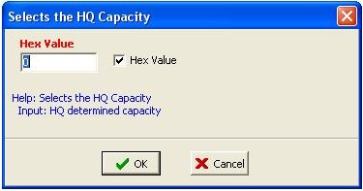
- Set HQ capacity.

This function manually set the HQ capacity. It accepts value in hex format. If you not have experience about using of this function then not try to use it. It manually changes the setting of capacity which is set by ARCO.

- Set target capacity.
This function manually set the target capacity. It accepts value in hex format. If you not have experience then not plays with this. It manually changes the setting of capacity which is set by ARCO.
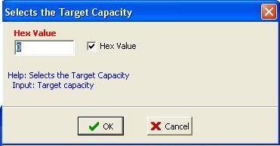

- Set capacity
This function manually set the capacity which is available in sector formatting later we will discuss it. It accepts value in hex format. If you not have experience then not plays with this. It manually changes the setting of capacity which is set by ARCO. If hard disk has one head then enter value in first integer and so on.

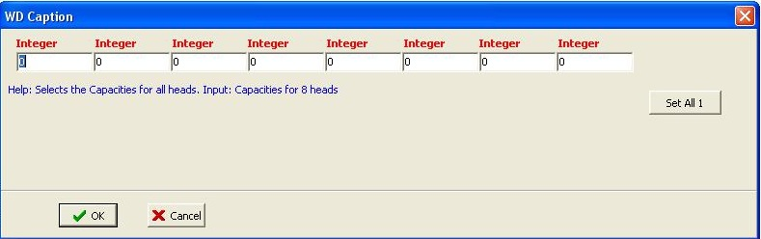
- Set DCM.
DCM set all the values of hard disk to its factory default setting.
(DCM not clear logs and defect list, it removes all ARCO setting from hard disk information).
Default value for DCM = 1.
- Get DCM.
It shows which DCM value is already set.
- SET TPI.
It is same like set capacity.

8. Main.
- LBA G list
This function is used to put LBA into g list directly.

- Clear G list and relocate.
This function used to clear G list and its translator if hard disk is slow responding. It clears modules directly.
- F list edit.
Field list has a very important role in hard disk refurbishing or repairing. It saves the capacity for all head which is available in hard disk ROM. Whenever you cut head it will auto select the downgrade capacity which is best for remaining heads. If field list is not having good capacity, then it will not set the proper capacity and in result you face many errors.
e.g.
If you start ARCO tests on hard disk and forgot to set proper capacity for heads then 6a 6f 6b tests passed ok, but test 69 will stuck which is known as sector density.
e.g.
If a hard disk has 4 heads and 80 GB capacity for each head and total capacity is 320 GB. Now in F list it is important that every head has its capacity in that method which is below
Head 1 = 80 GB
Head 2 = 160 GB
Head 3 = 250 GB Head 3 = 350 GB
Head 4 = 320 GB
Now if you cut head 1 of a hard disk, then it changes all things and it load capacity from F list and save it in to the hard disk passport which is 250 GB. But if capacity for head 3 is 350 GB then it select 350 GB capacity and save it in hard disk passport. And after that whenever you try to format hard disk with P list it gives you error FMT_ERR_CAPACITY. Then you need to change capacity from F list manually.
How to Set F list?
In field list there are few sets of capacity named as STD, ALT1, ALT2, ALT3, ALT4 and ALT5. Every set store capacity of 8 heads, like
1 head = 80
2 head = 160
3 head = 240
4 head = 320
5 head = 400
6 head = 480
7 head = 560
8 head = 640
Now assume that this capacity is store in STD of field list.
Now here one more question rise. If this is STD capacity sequences then why field list use ALT 1, ALT 2, and others?
Here is the answer through example. I already write above that sector density which is Arco test number (69) use capacity from field list. If STD has 80 GB in head 1 then in ALT 1 we need to reduce capacity by half of this capacity which is 40 GB and so on. By doing this when a sector density run normally, And if it found bad zones then it automatically cut it and reduce the capacity and get the downgrade capacity from field list and save it in hard disk VKFCI log and later it save it into hard disk passport.
STD ALT 1 ALT 2
Head 1 =80 head 1 = 60 head 1 = 40
Head 2 = 160 head 2 = 120 head 2 =80
Head 3 = 240 head 3 = 200 head 3 =160
Head 4 = 320 head 4 =250 head 4 =200
Head 5 = 400 head 5 = 320 head 5 =250
Head 6 = 480 head 6 = 400 head 6 =350
Head 7 = 560 head 7 = 500 head 7 =450
Head 8 = 640 head 8 = 550 head 8 = 500

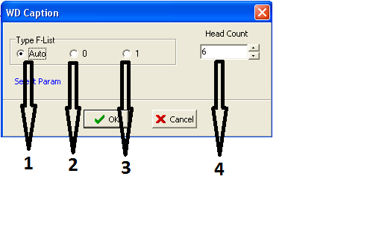

- If you select auto and click on ok then it open field list with 8 head for every ALT.
- If you select this then it load all things from head 0.
- If you select this then it load all things from head 1.
- The default option for this function is 6 heads. If you change head count to 1 and select auto radio button then press ok then it load capacity set for all ALT only for head 1 for example (STD for head 1, ALT 1 for head, ALT 2 for head 1) and it will not show other head. The purpose of this function is to make field list easy and user friendly.
MAIN SCREEN OF FIELD LIST.
- Capacity for STD (MAIN) heads.
- Capacity for ALT 1 heads.
- Capacity for ALT 2 heads.
- Capacity for STD (main) which is always full value of hard disk.
- Capacity for ALT 1 is reduced by 25 percent and saved in ALT 1.
- Capacity for ALT 2 is reduced by 50 percent and saved in ALT 2.
- Capacity for ALT 3 is reduced by 50 percent and saved in ALT 3.
- Capacity for ALT 4 is reduced by 50 percent and saved in ALT 4.
- Capacity for ALT 5 is reduced by 50 percent and saved in ALT 5.
- This button load hard disk model number from module number 2 and save it in STD (main) so after Arco hard disk model not change.
- This button gets capacity from hard disk info and auto set capacities in all ALT.
- If you check this function then press set capacity then it will change all capacity in field list except capacity in STD (main).
- If you select this check box and press set capacity then it set capacity in all ALT only for those heads which are available in ROM.
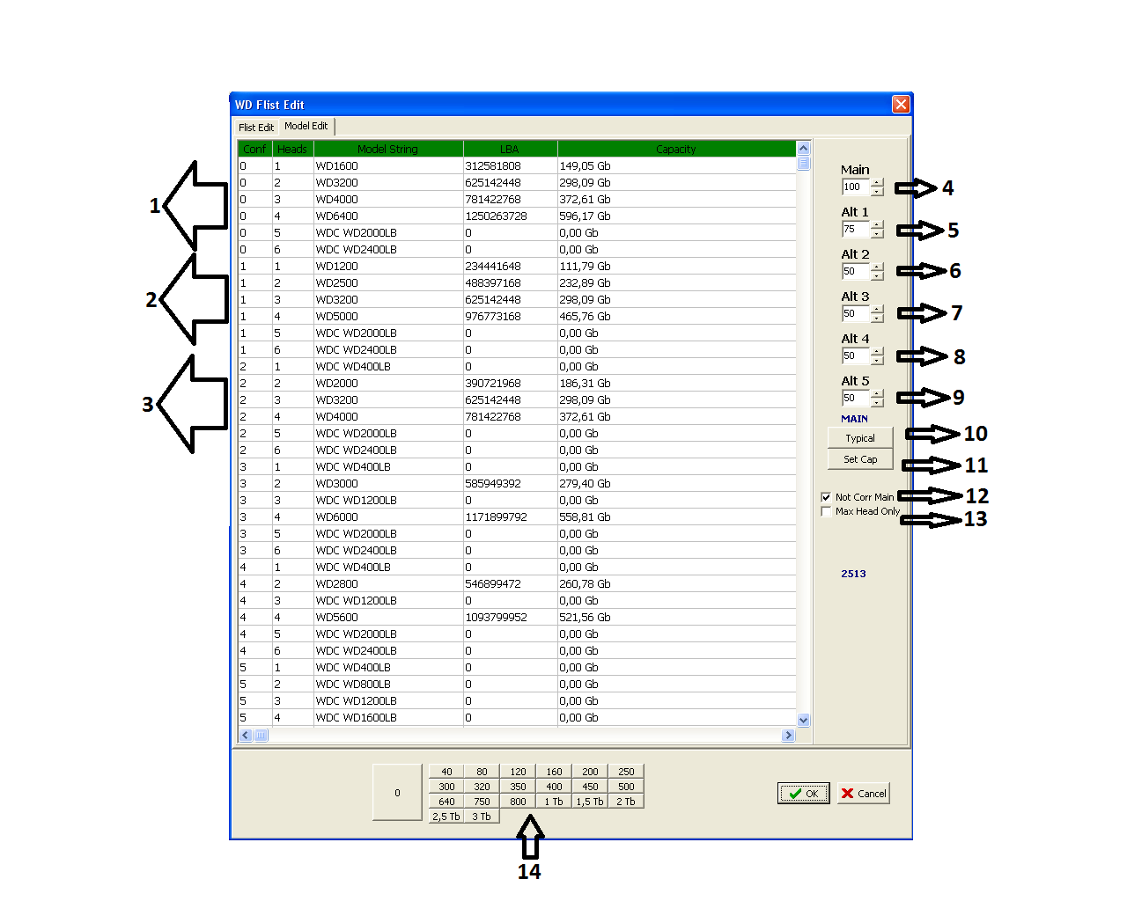
- These are capacities, click on any ALT head and then select capacity, it put selected capacity into selected ALT head.

- INIT head 0.
This function is used to initialize directory module from head 0 and gives you access to service area.
Some time when you cut head of a hard disk and reset power ,after that it click and spin down not giving access to service area this is because some time defect list modules gives error and in return head click and hard disk spin down. In that situation you need to load hard disk in safe mode and then use this function, it will initialize directory module from head 0 and gives you access to service and then you can change the damage module from the hard disk and recover data or repair it.
- INIT head 1.
It is same like head 0 initialize. Difference is that head 0 initialize read directory from copy 0 and head 1 initialize read directory module from copy 1.
- Load 11 overlay (from surface).
This function is used to load ATA overlay from hard disk surface.
- Load overlay 13 (from surface).
This function is used to load overlay number 13 from hard disk surface.
- Create LDR.
This function is used to create loader file from hard disk surface.

10. SA operation.
- SELF SA (DF module).
This function is used as self scan of service area. It scans service area in safe mode and normal mode and adds defect into SA list (module number 35) and regenerate translator in ROM (module # 30).

Definition:-
It scan full service area of a hard disk and put bad sectors or tracks in to SA list and regenerate translator or modules in ROM and service area.

Self SA in safe mode.
If you want to run self scan SA in safe mode then you must need to upload ATA overlay (module # 11) in ram, otherwise self SA not start.
Self SA in normal mode.
This is online self scan SA. For online self scan no need to upload ATA overlay.
NOTE: After self scan SA, must do format SA with newly generated SA list. If you need data then don’t use it, it will destroy data.

How to start Self scan SA?
When your hard disk is detecting properly and you want to run self scan SA simple click on SELF SA, it will open new tab asking for LOAD OVERLAY, if your hard disk is in detection then no need to upload overlay click on cancel, then it will ask for LOAD MINI IBI OPTION, from surface or from external file chose your required option and press ok. It will start test and you will see progress in status window.
It normally takes 2 minutes.

- SA format.
SA format stand for service area format. It is used to format reserved area and it will leave 01 and 35 module in directory.

Definition:-
It use SA defect list and get error from SA list and if the bad sector in the SA list are under the limit (not support large quantity of bad) then it format service area and rearrange firmware regions to new location. So when you upload firmware modules, it read and writes firmware modules properly.
Note: if you need data then don’t use this function.
Why we use SA format and what changes appeared after SA format?
Let we start it with a hard disk which has 4 heads and it is in clicking state. It has 4 heads and one head is damaged that’s why hard disk is clicking. Now first of all we need to disable damaged head from ROM and disable its adaptive (see adaptive section for details) from ROM, and reset power.
Now the hard disk is running with 3 heads and original heads are 4, now we need to change all defect list translator (module # 30 from ROM) and region to work for 3 heads.
Now in this situation self scan SA regenerate translator in ROM (module # 30) and recreate SA list (module # 35), and format SA, format service area by getting information from module number 30 of ROM and from SA list 35 and re create firmware regions for remaining heads.
How to format SA?
When you click on format SA it will ask you for load overlay from surface or file choose your required option, then it will ask you for SA list option if internal SA list damaged then you can use external SA list to format SA. For more details see its functionality in general problems section.
- SA translator recalculation.
It used to recalculate translator of ROM (module # 30) by using SA list (module # 35). It runs only on that hard disk which is detecting properly, and it read firmware from the surface, if firmware damaged then this translator not work. In this kind of situation see next function detail.
NOTE: if you need data then don’t try to use it.

- Soft SA translator recalculation (Original).
It is a soft SA translator recalculation it uses only SA list from surface of hard disk and use it for translator recalculation and save it in ROM (module number 30).
What is the main purpose of this function?
In some cases SA list have many bad sector and it is not possible to regenerate translator or format SA, then this function helps you for the recalculation of translator quickly.
- Soft SA translator recalculation (detail).
As above. Difference is that it recalculate translator in detail and have greater power.
- SA module repair.
This function is used to repair modules (setting of modules) after head cut to stop hard disk knock and spin down.
It is recommended to use this function always whenever you cut head of a WD hard disk.
- Create info file firmware.
This function is used to create a hard disk information file which has a record of firmware code model number etc.
- Unlock execute command.
This function is used to unlock self scan and ARCO on latest hard disk. A power reset is compulsory to see the effect of this function.

11. Directory manager.
- Load directory and write fast.

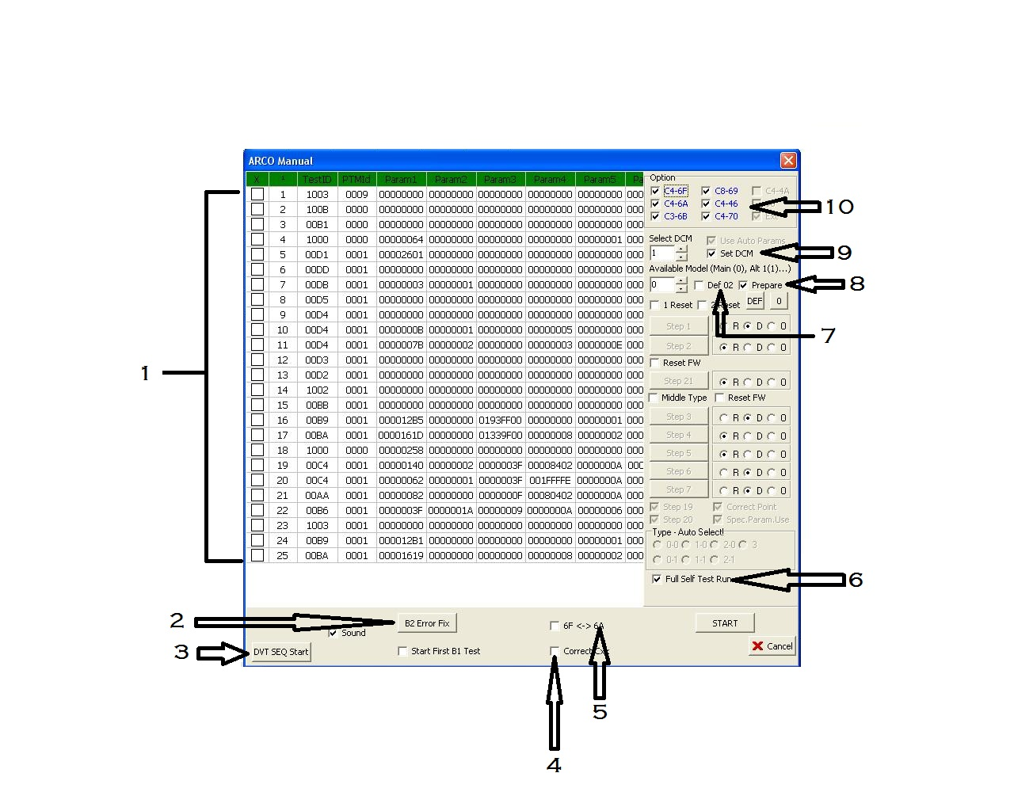
- ARCO MANUAL

- Self scan test ids which is available in module 28.
- B2 error fix. it is used to fix B2 error which is available in self scan script (module 28)
- It start DVT test first
- It corrects Cxx module parameters before running ARCO.
- ARCO sequence for maximum hard disk is 6f 6a 6b 69 46. But some hard disk not support this sequence so this function is used it change the sequence auto, it first start 6a then 6f 6b 69 46.
- If this is unable then complete self scan test run which is available in module 28 which is also known as self scan script.
- This function edit module number 02 which is called hard disk id module contain hard disk model and serial number. When you check this function and start ARCO it changes hard disk model number to xyz and serial number 0000. Some hard disk not supports module 02 changes.
- This option used to prepare all modules to run ARCO. By select this option and start ARCO first it clear all logs of ARCO (20xx modules) and all SS logs, if you not select this and start ARCO then it start ARCO without clearing modules.
- This option is used to set the corresponding DCM value. Recommended value is 1 it set hard disk information to its factory settings.
- Now this is a newly added function for ARCO which auto load all ARCO set from hard disk logs, if logs are empty then these test not appear. This section of ARCO work only if ARCO result modules are not empty (20XX modules). You can select or deselect any test which you not want to run.

Chart for manual ARCO.

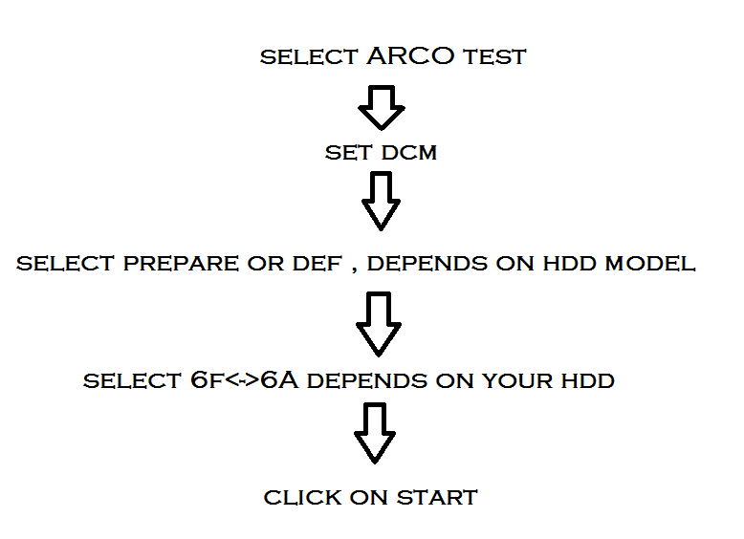

After start manual ARCO what it changes.
- Clear Arco logs (20XX modules)
- Clear SF logs.
- Clear all defect lists
- Set DCM to 1 and set all parameter to factory default setting if you set prepare function otherwise it only clear logs.
- If u set DEF function then it changes its id model to its factory setting.
- Unlock self scan which is in latest hard disk.
- Start ARCO.
- Wait for its finish, after complete ARCO from 6f 6a 6b 69 46 you can remove hard disk from software and plug it on separate power supply for 12 hour. Because self scan test run in background auto.

